# Model Comparison Study

Dataset: xmethanewet; ID: AT.Neu; Year: 2010; Variable: FCH4_F_ANNOPTLM

This document presents pairwise comparisons of synthetic model predictions. For each comparison, choose which time series better matches the ground truth.

## Comparison 1: TS 14 vs TS 19

Which time series better matches the ground truth?

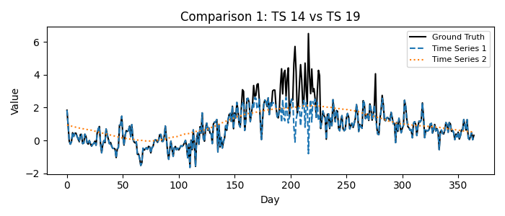

1 = Time Series 14, 2 = Time Series 19

Please fill in your choice (enter 1 or 2): _1_

## Comparison 2: TS 0 vs TS 6

Which time series better matches the ground truth?

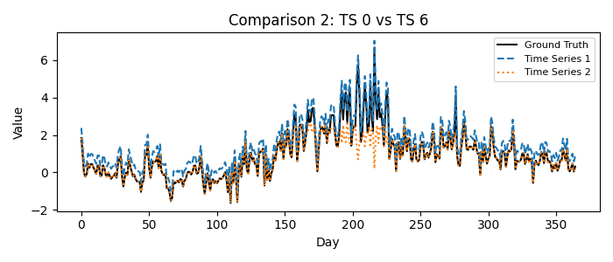

1 = Time Series 0, 2 = Time Series 6

Please fill in your choice (enter 1 or 2): 1__

## Comparison 3: TS 5 vs TS 11

Which time series better matches the ground truth?

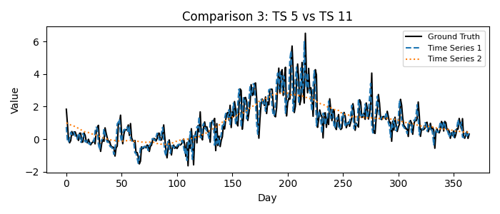

1 = Time Series 5, 2 = Time Series 11

Please fill in your choice (enter 1 or 2): _1_

## Comparison 4: TS 10 vs TS 16

Which time series better matches the ground truth?

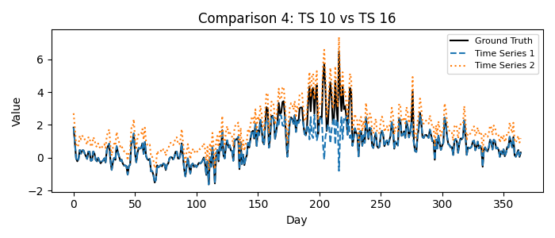

1 = Time Series 10, 2 = Time Series 16

Please fill in your choice (enter 1 or 2): 2__

## Comparison 5: TS 16 vs TS 18

Which time series better matches the ground truth?

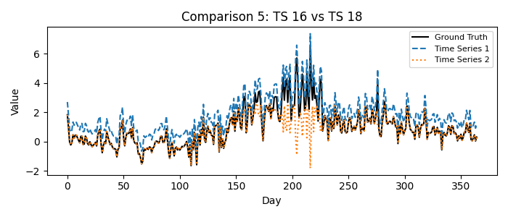

1 = Time Series 16, 2 = Time Series 18

Please fill in your choice (enter 1 or 2): _1_

## Comparison 6: TS 14 vs TS 15

Which time series better matches the ground truth?

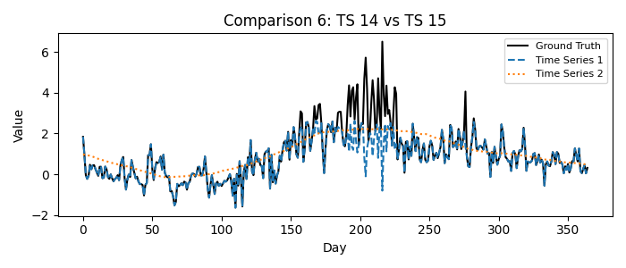

1 = Time Series 14, 2 = Time Series 15

Please fill in your choice (enter 1 or 2): _1_

## Comparison 7: TS 12 vs TS 18

Which time series better matches the ground truth?

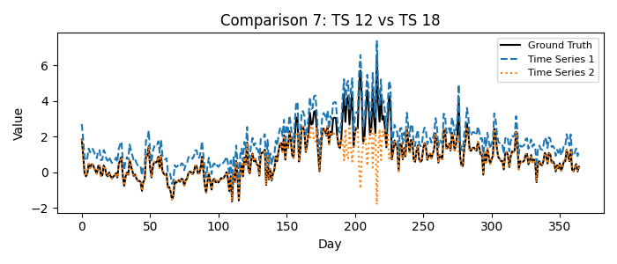

1 = Time Series 12, 2 = Time Series 18

Please fill in your choice (enter 1 or 2): 1__

## Comparison 8: TS 17 vs TS 19

Which time series better matches the ground truth?

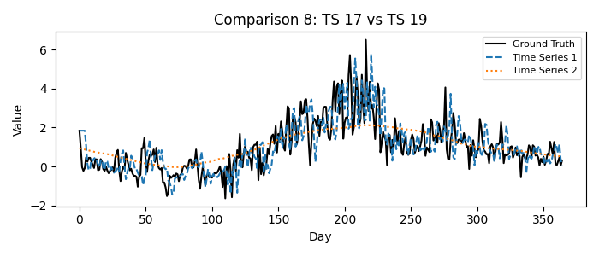

1 = Time Series 17, 2 = Time Series 19

Please fill in your choice (enter 1 or 2): 1__

## Comparison 9: TS 1 vs TS 13

Which time series better matches the ground truth?

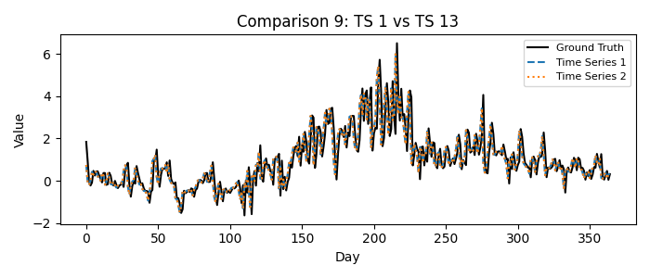

1 = Time Series 1, 2 = Time Series 13

Please fill in your choice (enter 1 or 2): _2_

## Comparison 10: TS 2 vs TS 7

Which time series better matches the ground truth?

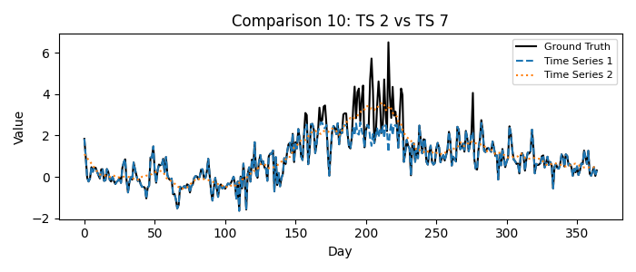

1 = Time Series 2, 2 = Time Series 7

Please fill in your choice (enter 1 or 2): _2_

## Comparison 11: TS 4 vs TS 7

Which time series better matches the ground truth?

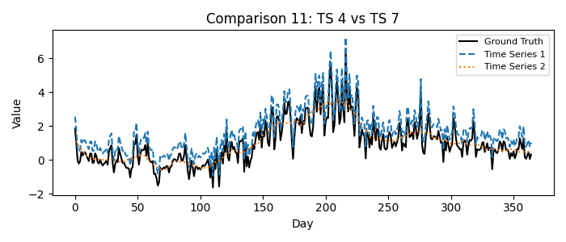

1 = Time Series 4, 2 = Time Series 7

Please fill in your choice (enter 1 or 2): _1_

## Comparison 12: TS 3 vs TS 4

Which time series better matches the ground truth?

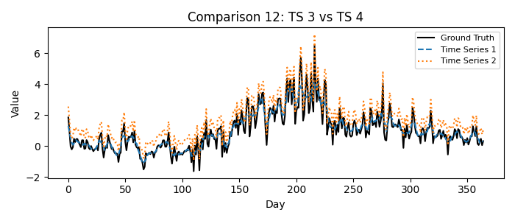

1 = Time Series 3, 2 = Time Series 4

Please fill in your choice (enter 1 or 2): _1_

## Comparison 13: TS 9 vs TS 15

Which time series better matches the ground truth?

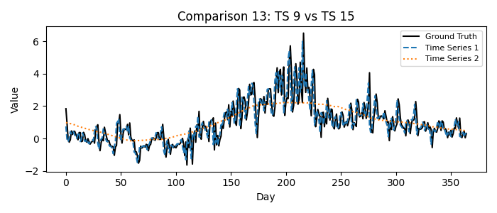

1 = Time Series 9, 2 = Time Series 15

Please fill in your choice (enter 1 or 2): _1_

## Comparison 14: TS 5 vs TS 8

Which time series better matches the ground truth?

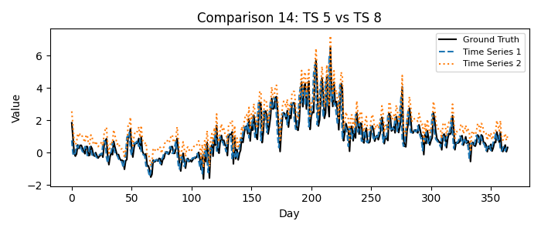

1 = Time Series 5, 2 = Time Series 8

Please fill in your choice (enter 1 or 2): __1

## Comparison 15: TS 2 vs TS 8

Which time series better matches the ground truth?

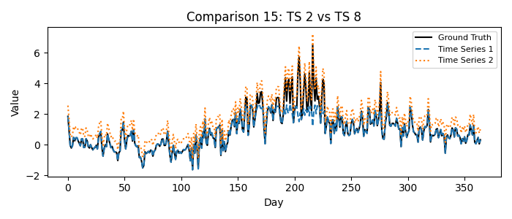

1 = Time Series 2, 2 = Time Series 8

Please fill in your choice (enter 1 or 2): _2_

## Comparison 16: TS 0 vs TS 3

Which time series better matches the ground truth?

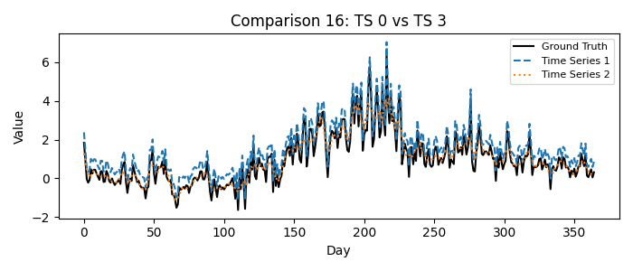

1 = Time Series 0, 2 = Time Series 3

Please fill in your choice (enter 1 or 2): _1_

## Comparison 17: TS 8 vs TS 9

Which time series better matches the ground truth?

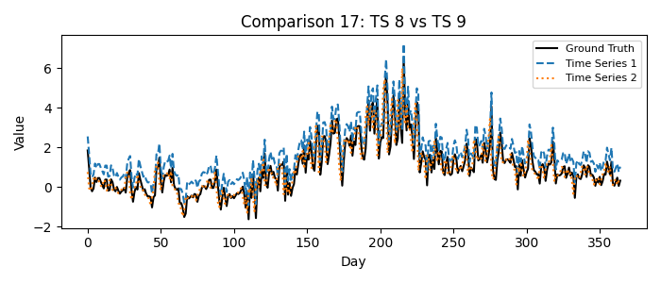

1 = Time Series 8, 2 = Time Series 9

Please fill in your choice (enter 1 or 2): _2_

## Comparison 18: TS 12 vs TS 15

Which time series better matches the ground truth?

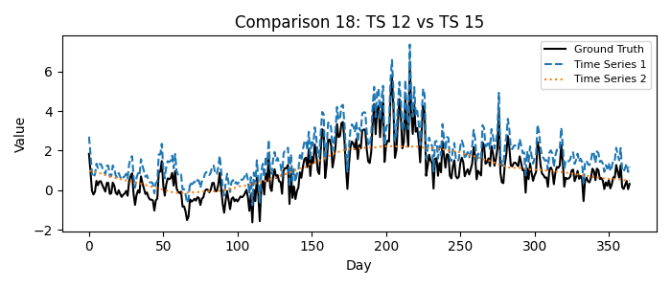

1 = Time Series 12, 2 = Time Series 15

Please fill in your choice (enter 1 or 2): 1__

## Comparison 19: TS 1 vs TS 6

Which time series better matches the ground truth?

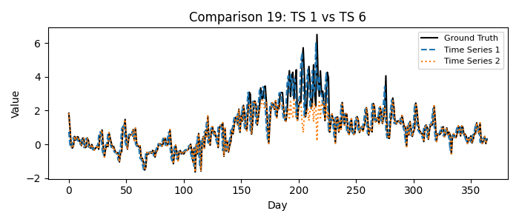

1 = Time Series 1, 2 = Time Series 6

Please fill in your choice (enter 1 or 2): _1_

## Comparison 20: TS 9 vs TS 11

Which time series better matches the ground truth?

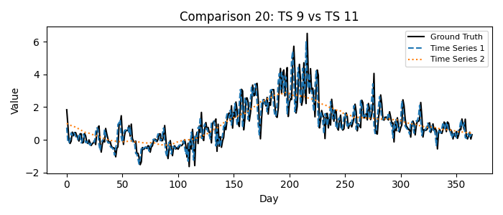

1 = Time Series 9, 2 = Time Series 11

Please fill in your choice (enter 1 or 2): 1__

## Comparison 21: TS 5 vs TS 10

Which time series better matches the ground truth?

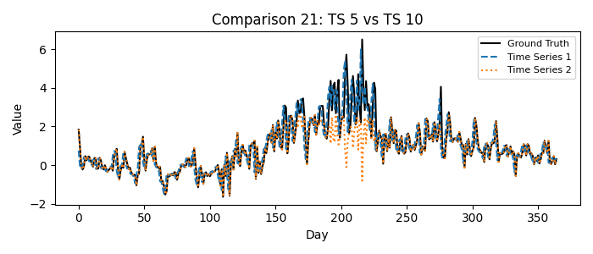

1 = Time Series 5, 2 = Time Series 10

Please fill in your choice (enter 1 or 2): _1_

## Comparison 22: TS 17 vs TS 18

Which time series better matches the ground truth?

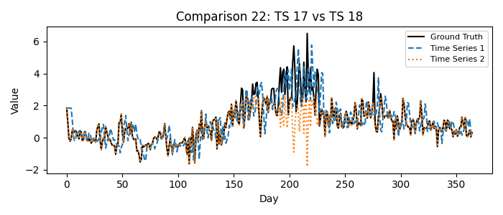

1 = Time Series 17, 2 = Time Series 18

Please fill in your choice (enter 1 or 2): _1_

## Comparison 23: TS 11 vs TS 13

Which time series better matches the ground truth?

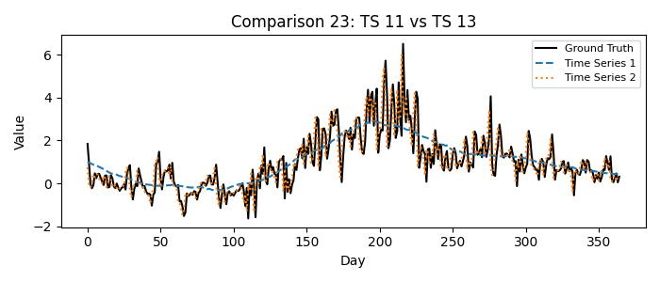

1 = Time Series 11, 2 = Time Series 13

Please fill in your choice (enter 1 or 2): _2_

## Comparison 24: TS 4 vs TS 6

Which time series better matches the ground truth?

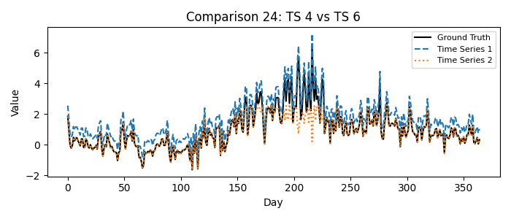

1 = Time Series 4, 2 = Time Series 6

Please fill in your choice (enter 1 or 2): _1_

## Comparison 25: TS 16 vs TS 17

Which time series better matches the ground truth?

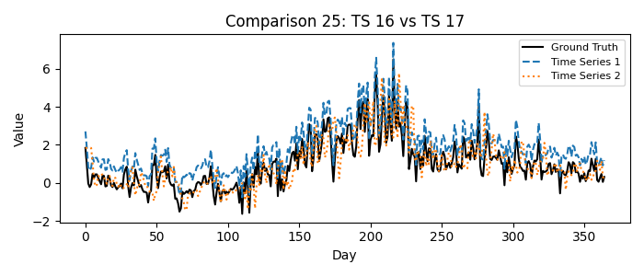

1 = Time Series 16, 2 = Time Series 17

Please fill in your choice (enter 1 or 2): __2

## Comparison 26: TS 9 vs TS 14

Which time series better matches the ground truth?

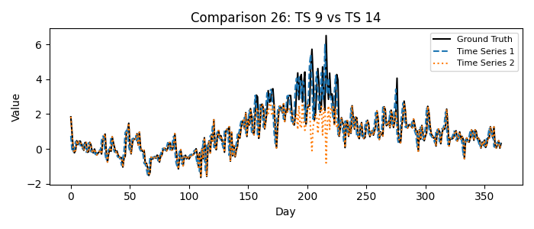

1 = Time Series 9, 2 = Time Series 14

Please fill in your choice (enter 1 or 2): _1_

## Comparison 27: TS 10 vs TS 12

Which time series better matches the ground truth?

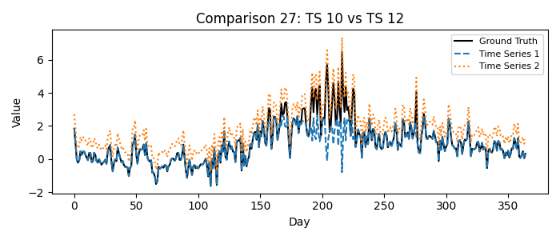

1 = Time Series 10, 2 = Time Series 12

Please fill in your choice (enter 1 or 2): __2

## Comparison 28: TS 1 vs TS 4

Which time series better matches the ground truth?

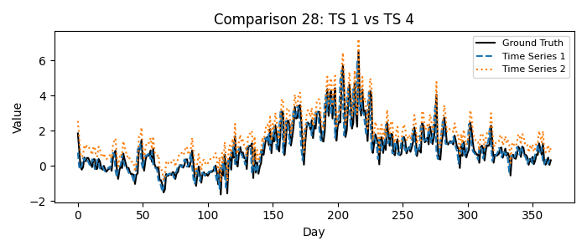

1 = Time Series 1, 2 = Time Series 4

Please fill in your choice (enter 1 or 2): __1

## Comparison 29: TS 13 vs TS 15

Which time series better matches the ground truth?

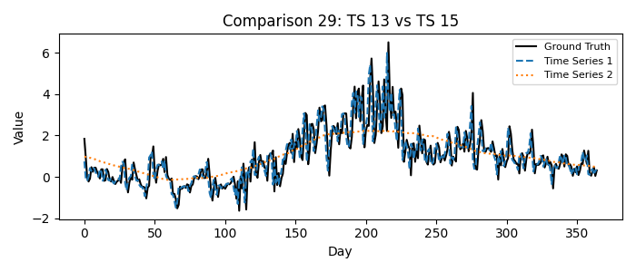

1 = Time Series 13, 2 = Time Series 15

Please fill in your choice (enter 1 or 2): __1

## Comparison 30: TS 0 vs TS 7

Which time series better matches the ground truth?

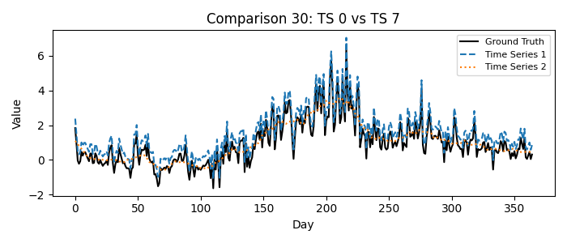

1 = Time Series 0, 2 = Time Series 7

Please fill in your choice (enter 1 or 2): __1

## Comparison 31: TS 18 vs TS 19

Which time series better matches the ground truth?

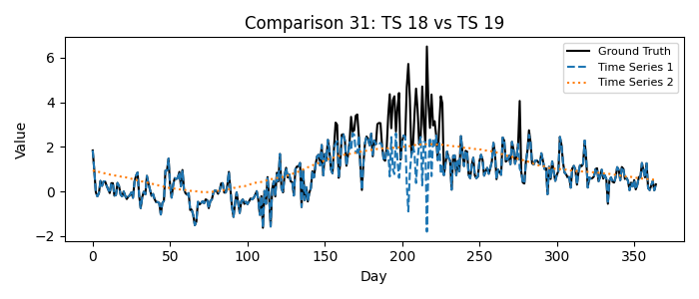

1 = Time Series 18, 2 = Time Series 19

Please fill in your choice (enter 1 or 2): _1_

## Comparison 32: TS 2 vs TS 3

Which time series better matches the ground truth?

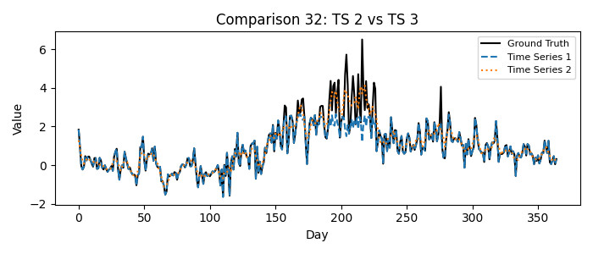

1 = Time Series 2, 2 = Time Series 3

Please fill in your choice (enter 1 or 2): _2_

## Comparison 33: TS 14 vs TS 16

Which time series better matches the ground truth?

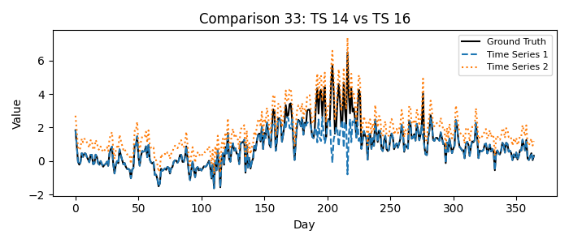

1 = Time Series 14, 2 = Time Series 16

Please fill in your choice (enter 1 or 2): _2_

## Comparison 34: TS 7 vs TS 11

Which time series better matches the ground truth?

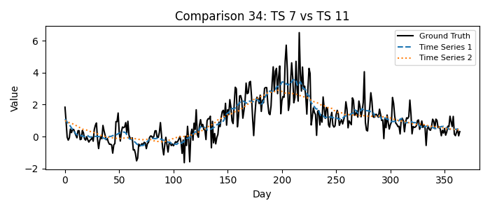

1 = Time Series 7, 2 = Time Series 11

Please fill in your choice (enter 1 or 2): 1__

## Comparison 35: TS 1 vs TS 5

Which time series better matches the ground truth?

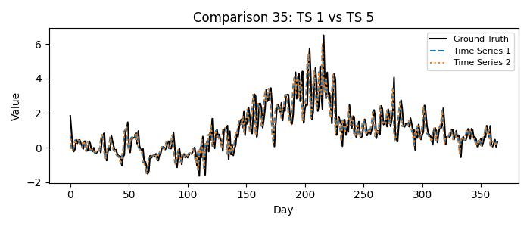

1 = Time Series 1, 2 = Time Series 5

Please fill in your choice (enter 1 or 2): 2__

## Comparison 36: TS 12 vs TS 17

Which time series better matches the ground truth?

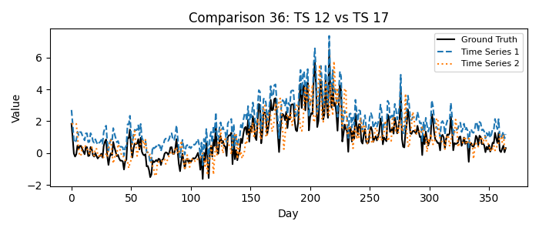

1 = Time Series 12, 2 = Time Series 17

Please fill in your choice (enter 1 or 2): 2__

## Comparison 37: TS 2 vs TS 6

Which time series better matches the ground truth?

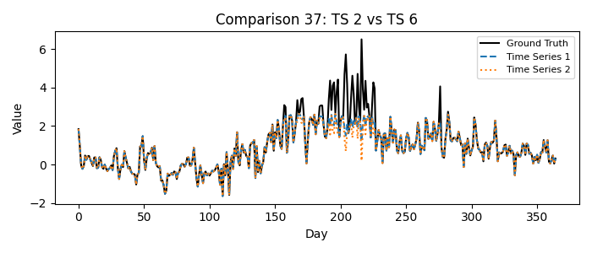

1 = Time Series 2, 2 = Time Series 6

Please fill in your choice (enter 1 or 2): __1

## Comparison 38: TS 7 vs TS 8

Which time series better matches the ground truth?

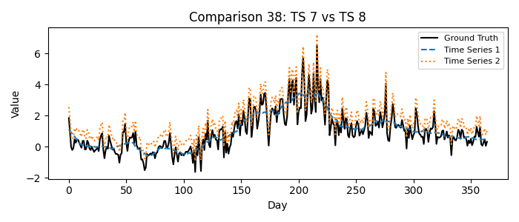

1 = Time Series 7, 2 = Time Series 8

Please fill in your choice (enter 1 or 2): __2

## Comparison 39: TS 15 vs TS 19

Which time series better matches the ground truth?

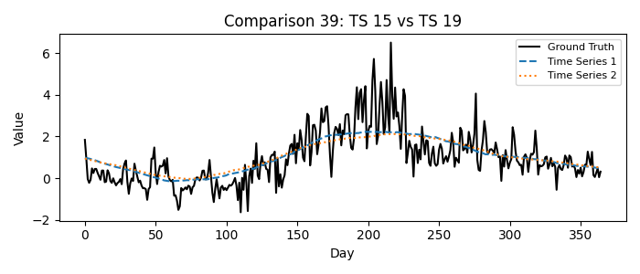

1 = Time Series 15, 2 = Time Series 19

Please fill in your choice (enter 1 or 2): __1

## Comparison 40: TS 0 vs TS 2

Which time series better matches the ground truth?

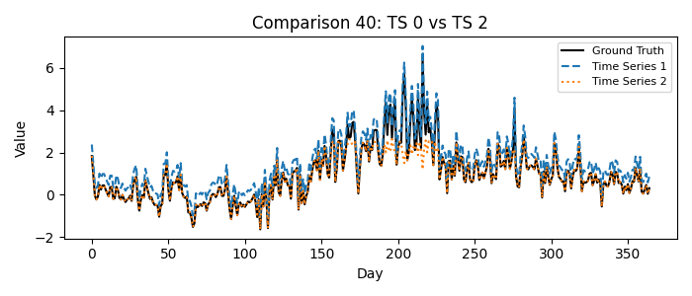

1 = Time Series 0, 2 = Time Series 2

Please fill in your choice (enter 1 or 2): 1__

## Comparison 41: TS 1 vs TS 10

Which time series better matches the ground truth?

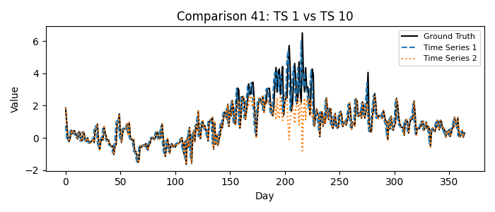

1 = Time Series 1, 2 = Time Series 10

Please fill in your choice (enter 1 or 2): 1__

## Comparison 42: TS 13 vs TS 14

Which time series better matches the ground truth?

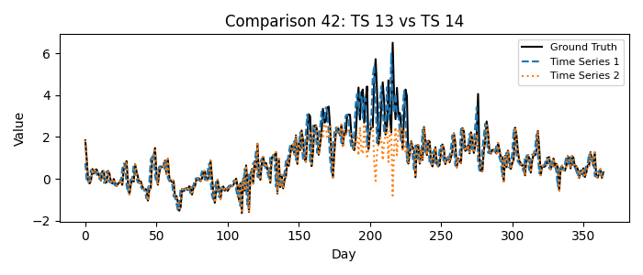

1 = Time Series 13, 2 = Time Series 14

Please fill in your choice (enter 1 or 2): _1_

## Comparison 43: TS 3 vs TS 7

Which time series better matches the ground truth?

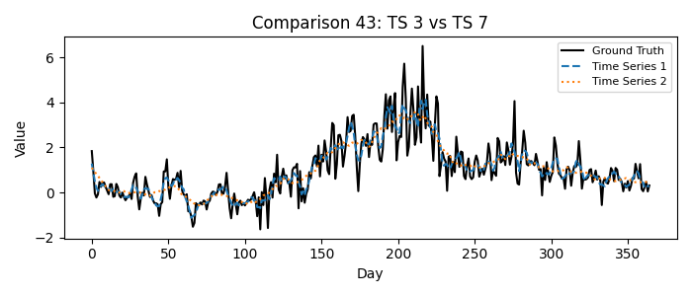

1 = Time Series 3, 2 = Time Series 7

Please fill in your choice (enter 1 or 2): _1_

## Comparison 44: TS 6 vs TS 7

Which time series better matches the ground truth?

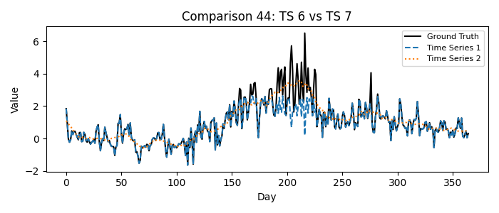

1 = Time Series 6, 2 = Time Series 7

Please fill in your choice (enter 1 or 2): __2

## Comparison 45: TS 15 vs TS 16

Which time series better matches the ground truth?

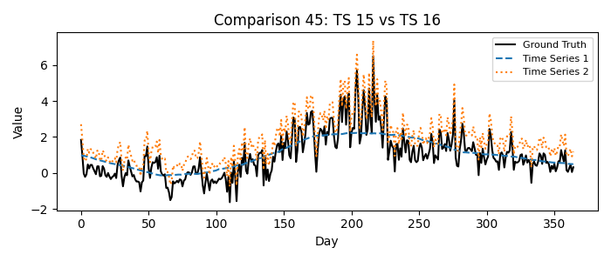

1 = Time Series 15, 2 = Time Series 16

Please fill in your choice (enter 1 or 2): _2_

## Comparison 46: TS 0 vs TS 17

Which time series better matches the ground truth?

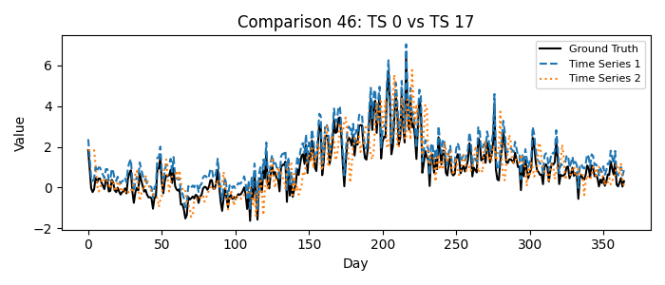

1 = Time Series 0, 2 = Time Series 17

Please fill in your choice (enter 1 or 2): __1

## Comparison 47: TS 12 vs TS 19

Which time series better matches the ground truth?

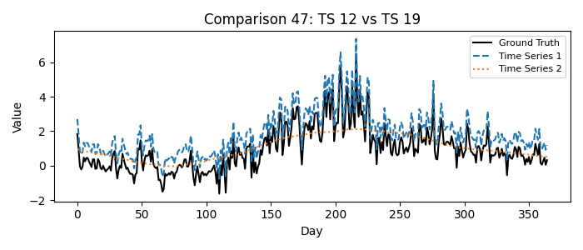

1 = Time Series 12, 2 = Time Series 19

Please fill in your choice (enter 1 or 2): 1__

## Comparison 48: TS 10 vs TS 15

Which time series better matches the ground truth?

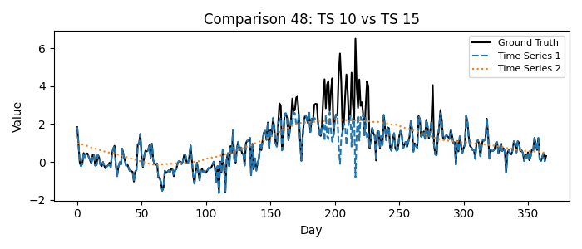

1 = Time Series 10, 2 = Time Series 15

Please fill in your choice (enter 1 or 2): __1

Comparison 49: TS 3 vs TS 6

Which time series better matches the ground truth?

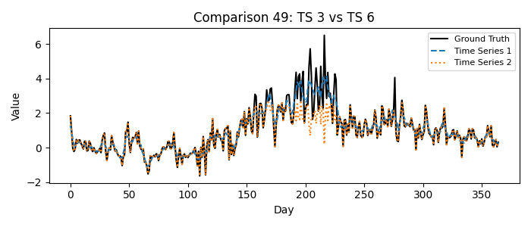

1 = Time Series 3, 2 = Time Series 6

Please fill in your choice (enter 1 or 2): _1_

## Comparison 50: TS 12 vs TS 13

Which time series better matches the ground truth?

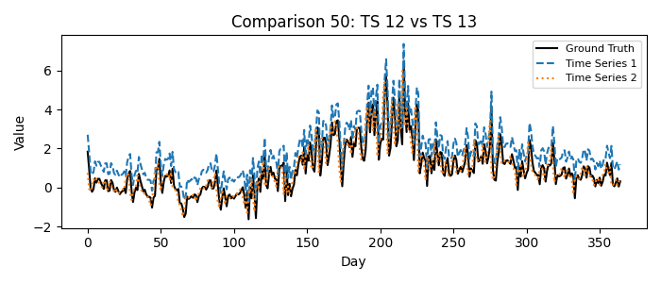

1 = Time Series 12, 2 = Time Series 13

Please fill in your choice (enter 1 or 2): _2_

## Comparison 51: TS 5 vs TS 9

Which time series better matches the ground truth?

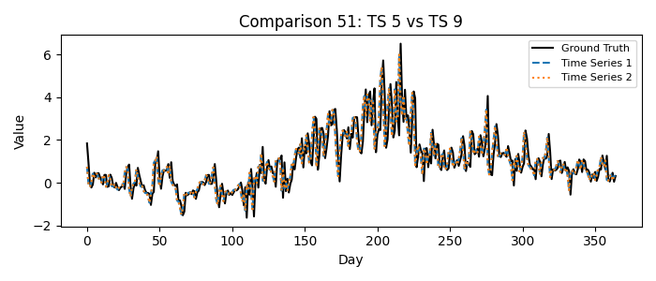

1 = Time Series 5, 2 = Time Series 9

Please fill in your choice (enter 1 or 2): __2

## Comparison 52: TS 4 vs TS 11

Which time series better matches the ground truth?

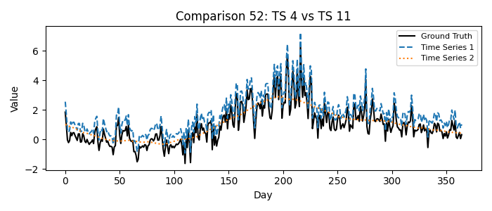

1 = Time Series 4, 2 = Time Series 11

Please fill in your choice (enter 1 or 2): __1

## Comparison 53: TS 15 vs TS 18

Which time series better matches the ground truth?

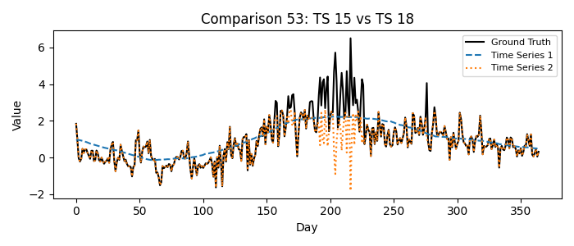

1 = Time Series 15, 2 = Time Series 18

Please fill in your choice (enter 1 or 2): __2

## Comparison 54: TS 8 vs TS 11

Which time series better matches the ground truth?

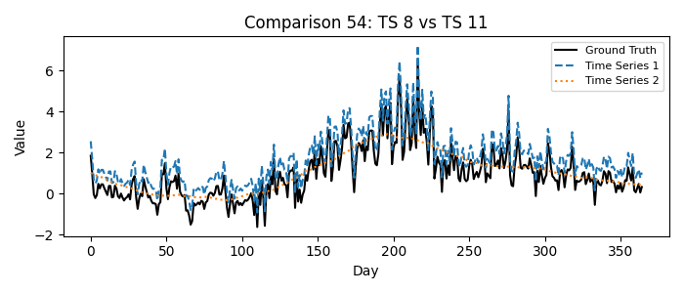

1 = Time Series 8, 2 = Time Series 11

Please fill in your choice (enter 1 or 2): _1_

## Comparison 55: TS 9 vs TS 13

Which time series better matches the ground truth?

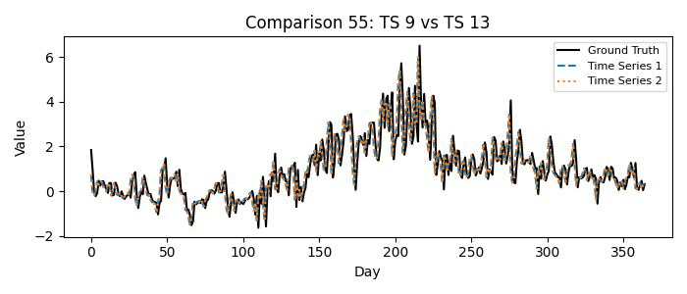

1 = Time Series 9, 2 = Time Series 13

Please fill in your choice (enter 1 or 2): __1

## Comparison 56: TS 0 vs TS 18

Which time series better matches the ground truth?

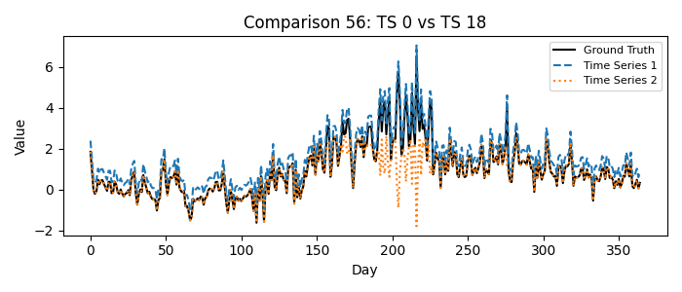

1 = Time Series 0, 2 = Time Series 18

Please fill in your choice (enter 1 or 2): 1__

## Comparison 57: TS 16 vs TS 19

Which time series better matches the ground truth?

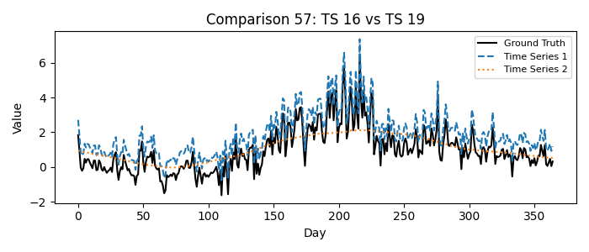

1 = Time Series 16, 2 = Time Series 19

Please fill in your choice (enter 1 or 2): __1

## Comparison 58: TS 2 vs TS 4

Which time series better matches the ground truth?

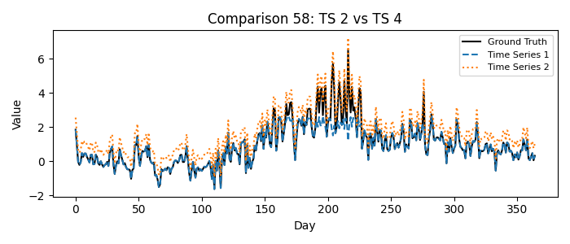

1 = Time Series 2, 2 = Time Series 4

Please fill in your choice (enter 1 or 2): 2__

## Comparison 59: TS 10 vs TS 13

Which time series better matches the ground truth?

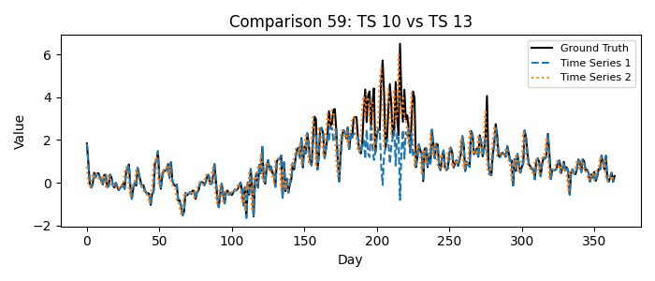

1 = Time Series 10, 2 = Time Series 13

Please fill in your choice (enter 1 or 2): _2_

## Comparison 60: TS 1 vs TS 3

Which time series better matches the ground truth?

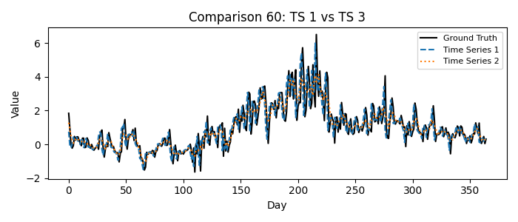

1 = Time Series 1, 2 = Time Series 3

Please fill in your choice (enter 1 or 2): __1

## Comparison 61: TS 12 vs TS 14

Which time series better matches the ground truth?

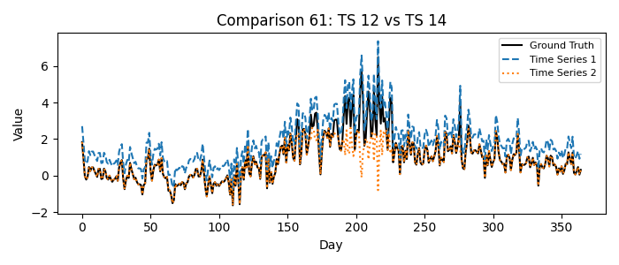

1 = Time Series 12, 2 = Time Series 14

Please fill in your choice (enter 1 or 2): _1_

## Comparison 62: TS 1 vs TS 17

Which time series better matches the ground truth?

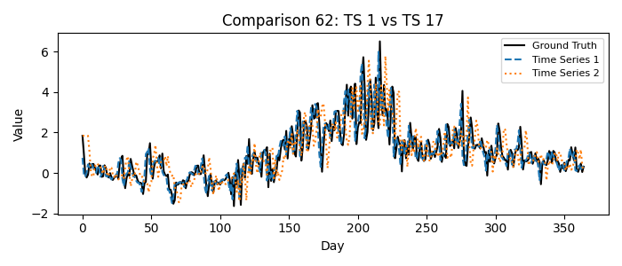

1 = Time Series 1, 2 = Time Series 17

Please fill in your choice (enter 1 or 2): _1_

## Comparison 63: TS 5 vs TS 13

Which time series better matches the ground truth?

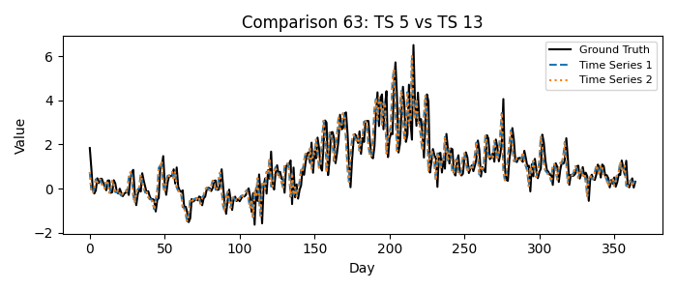

1 = Time Series 5, 2 = Time Series 13

Please fill in your choice (enter 1 or 2): _1_

## Comparison 64: TS 1 vs TS 8

Which time series better matches the ground truth?

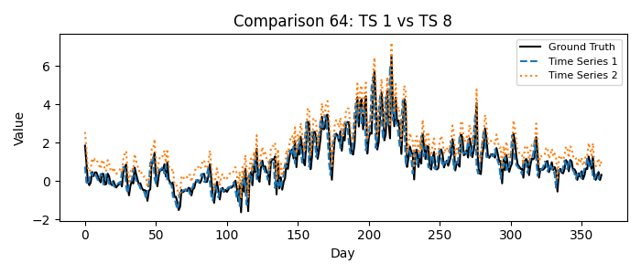

1 = Time Series 1, 2 = Time Series 8

Please fill in your choice (enter 1 or 2): _1_

## Comparison 65: TS 10 vs TS 14

Which time series better matches the ground truth?

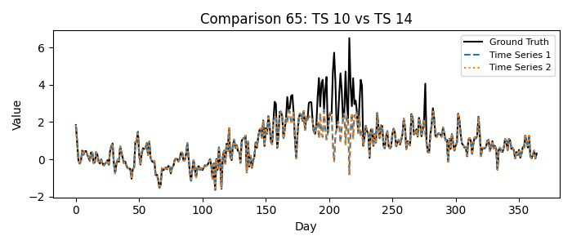

1 = Time Series 10, 2 = Time Series 14

Please fill in your choice (enter 1 or 2): __2

## Comparison 66: TS 1 vs TS 11

Which time series better matches the ground truth?

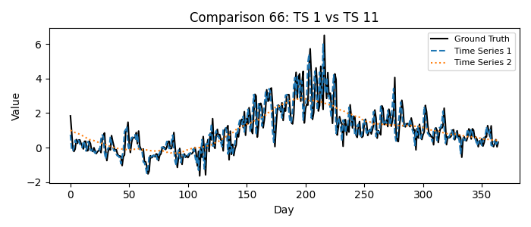

1 = Time Series 1, 2 = Time Series 11

Please fill in your choice (enter 1 or 2): _1_

## Comparison 67: TS 2 vs TS 17

Which time series better matches the ground truth?

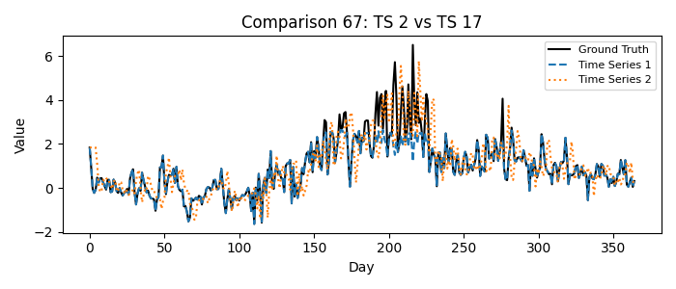

1 = Time Series 2, 2 = Time Series 17

Please fill in your choice (enter 1 or 2): 2__

## Comparison 68: TS 5 vs TS 14

Which time series better matches the ground truth?

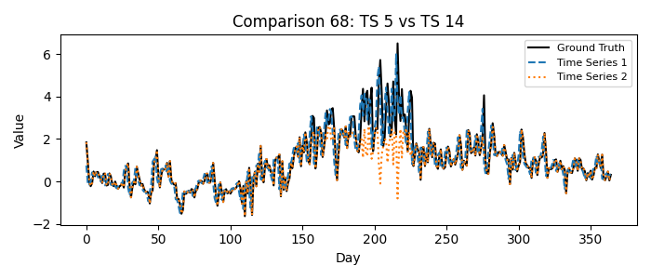

1 = Time Series 5, 2 = Time Series 14

Please fill in your choice (enter 1 or 2): __1

## Comparison 69: TS 0 vs TS 1

Which time series better matches the ground truth?

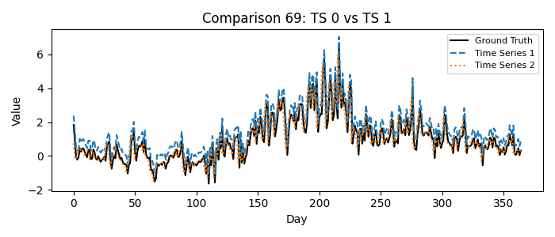

1 = Time Series 0, 2 = Time Series 1

Please fill in your choice (enter 1 or 2): __2

## Comparison 70: TS 1 vs TS 18

Which time series better matches the ground truth?

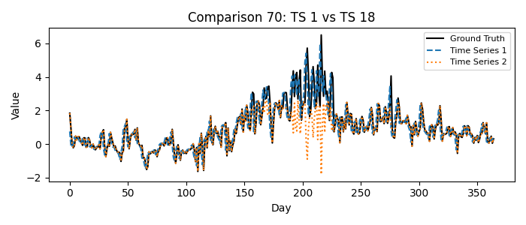

1 = Time Series 1, 2 = Time Series 18

Please fill in your choice (enter 1 or 2): __1

## Comparison 71: TS 6 vs TS 8

Which time series better matches the ground truth?

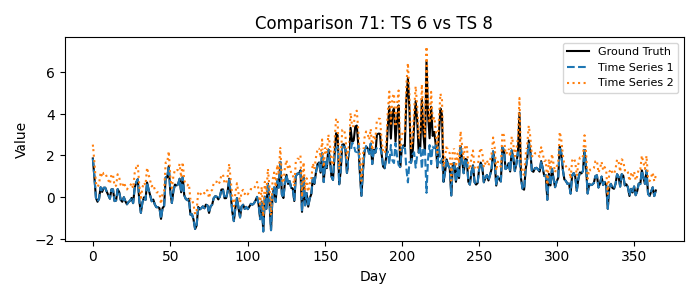

1 = Time Series 6, 2 = Time Series 8

Please fill in your choice (enter 1 or 2): __2

## Comparison 72: TS 0 vs TS 19

Which time series better matches the ground truth?

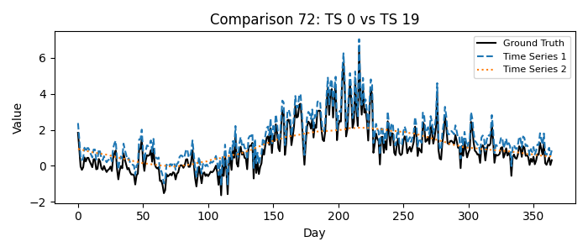

1 = Time Series 0, 2 = Time Series 19

Please fill in your choice (enter 1 or 2): _1_

## Comparison 73: TS 12 vs TS 16

Which time series better matches the ground truth?

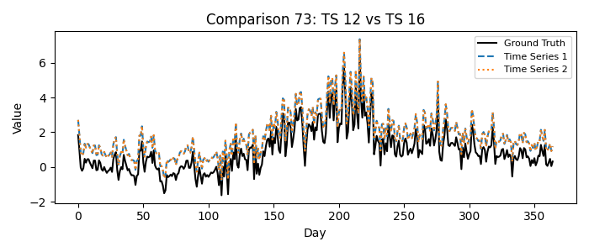

1 = Time Series 12, 2 = Time Series 16

Please fill in your choice (enter 1 or 2): __1

## Comparison 74: TS 3 vs TS 5

Which time series better matches the ground truth?

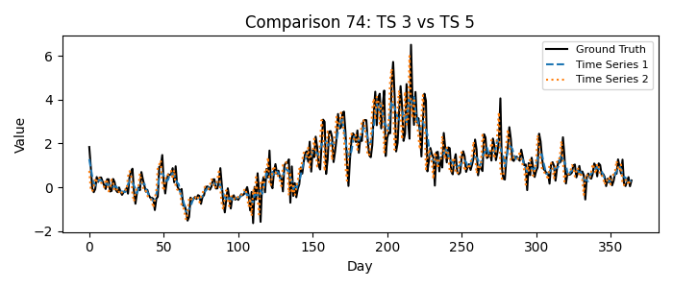

1 = Time Series 3, 2 = Time Series 5

Please fill in your choice (enter 1 or 2): __2

## Comparison 75: TS 4 vs TS 5

Which time series better matches the ground truth?

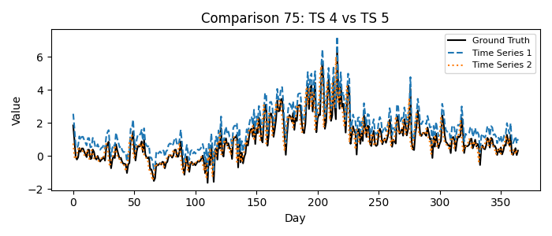

1 = Time Series 4, 2 = Time Series 5

Please fill in your choice (enter 1 or 2): _2_

## Comparison 76: TS 1 vs TS 9

Which time series better matches the ground truth?

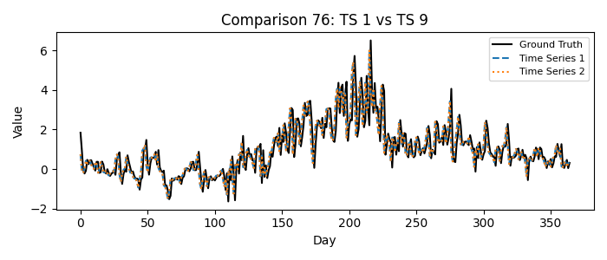

1 = Time Series 1, 2 = Time Series 9

Please fill in your choice (enter 1 or 2): _2_

## Comparison 77: TS 1 vs TS 2

Which time series better matches the ground truth?

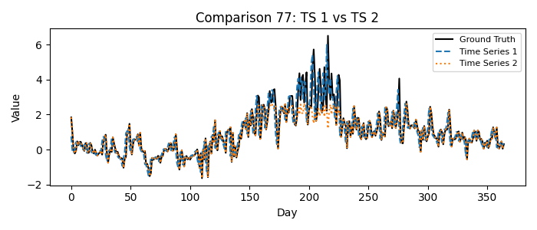

1 = Time Series 1, 2 = Time Series 2

Please fill in your choice (enter 1 or 2): _1_

## Comparison 78: TS 9 vs TS 10

Which time series better matches the ground truth?

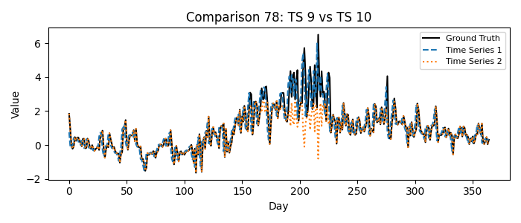

1 = Time Series 9, 2 = Time Series 10

Please fill in your choice (enter 1 or 2): _1_

## Comparison 79: TS 1 vs TS 19

Which time series better matches the ground truth?

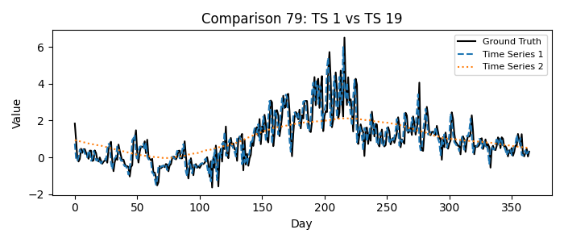

1 = Time Series 1, 2 = Time Series 19

Please fill in your choice (enter 1 or 2): __1

## Comparison 80: TS 4 vs TS 8

Which time series better matches the ground truth?

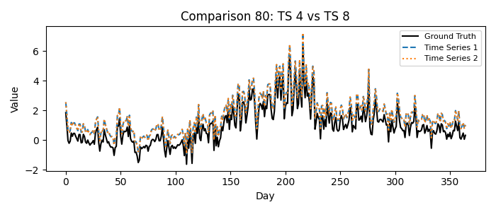

1 = Time Series 4, 2 = Time Series 8

Please fill in your choice (enter 1 or 2): _1_

## Comparison 81: TS 3 vs TS 8

Which time series better matches the ground truth?

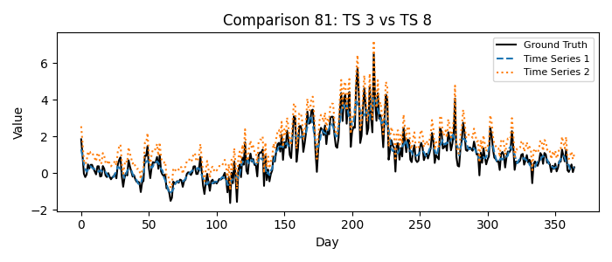

1 = Time Series 3, 2 = Time Series 8

Please fill in your choice (enter 1 or 2): _1_

## Comparison 82: TS 6 vs TS 11

Which time series better matches the ground truth?

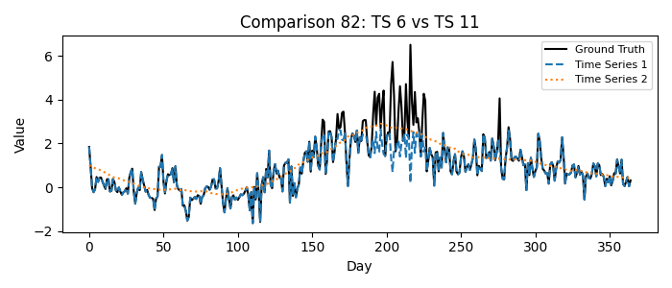

1 = Time Series 6, 2 = Time Series 11

Please fill in your choice (enter 1 or 2): _1_

## Comparison 83: TS 2 vs TS 18

Which time series better matches the ground truth?

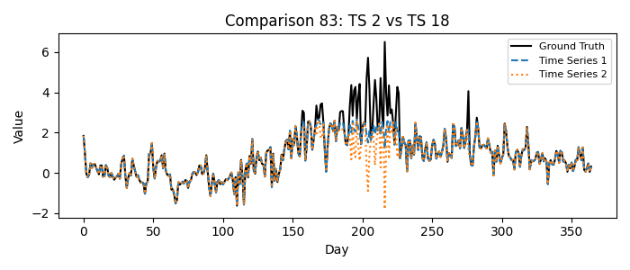

1 = Time Series 2, 2 = Time Series 18

Please fill in your choice (enter 1 or 2): 1__

## Comparison 84: TS 3 vs TS 17

Which time series better matches the ground truth?

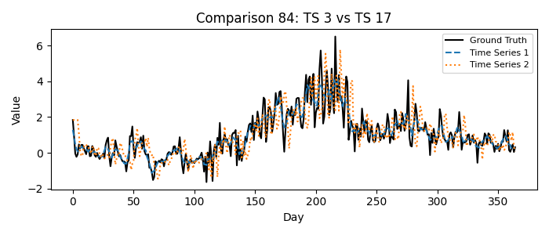

1 = Time Series 3, 2 = Time Series 17

Please fill in your choice (enter 1 or 2): _1_

## Comparison 85: TS 1 vs TS 7

Which time series better matches the ground truth?

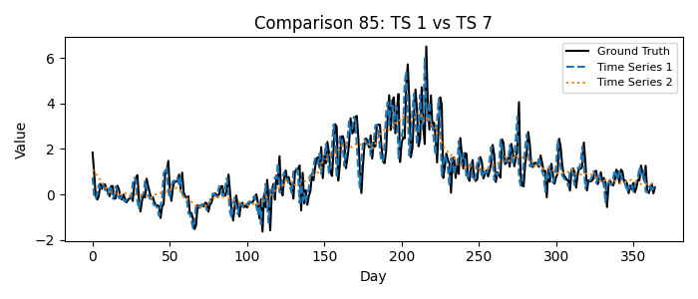

1 = Time Series 1, 2 = Time Series 7

Please fill in your choice (enter 1 or 2): _1_

## Comparison 86: TS 0 vs TS 16

Which time series better matches the ground truth?

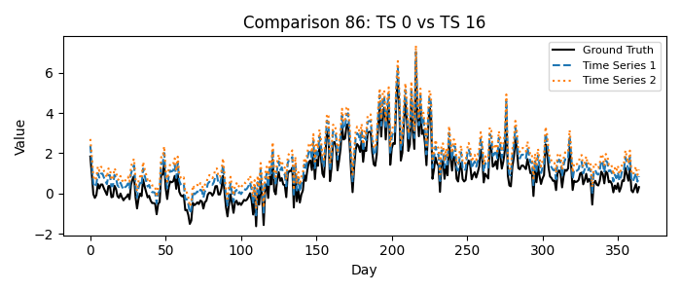

1 = Time Series 0, 2 = Time Series 16

Please fill in your choice (enter 1 or 2): 1__

## Comparison 87: TS 1 vs TS 16

Which time series better matches the ground truth?

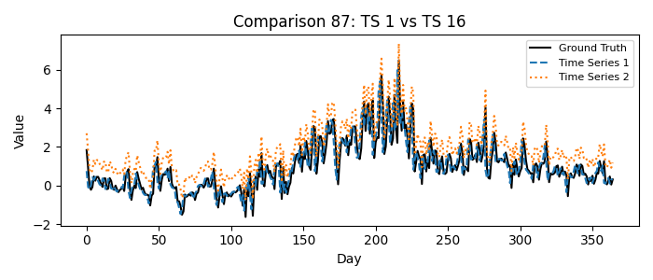

1 = Time Series 1, 2 = Time Series 16

Please fill in your choice (enter 1 or 2): __1

## Comparison 88: TS 2 vs TS 19

Which time series better matches the ground truth?

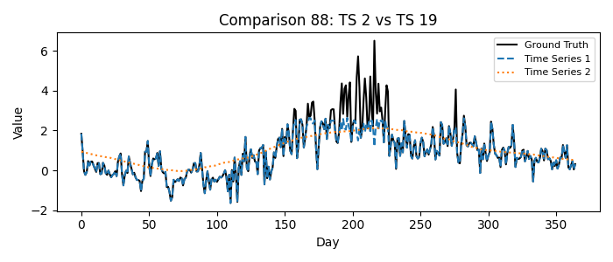

1 = Time Series 2, 2 = Time Series 19

Please fill in your choice (enter 1 or 2): __1

## Comparison 89: TS 3 vs TS 18

Which time series better matches the ground truth?

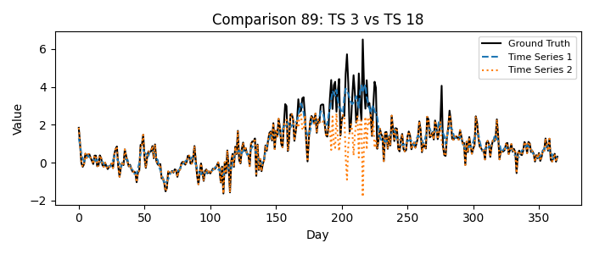

1 = Time Series 3, 2 = Time Series 18

Please fill in your choice (enter 1 or 2): __1

## Comparison 90: TS 0 vs TS 9

Which time series better matches the ground truth?

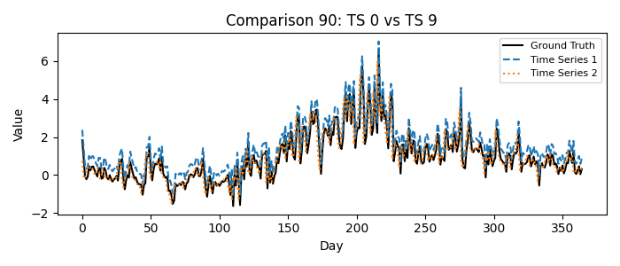

1 = Time Series 0, 2 = Time Series 9

Please fill in your choice (enter 1 or 2): 2__

## Comparison 91: TS 0 vs TS 13

Which time series better matches the ground truth?

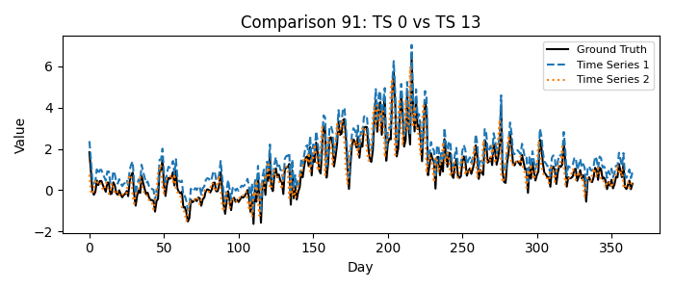

1 = Time Series 0, 2 = Time Series 13

Please fill in your choice (enter 1 or 2): __2

## Comparison 92: TS 5 vs TS 7

Which time series better matches the ground truth?

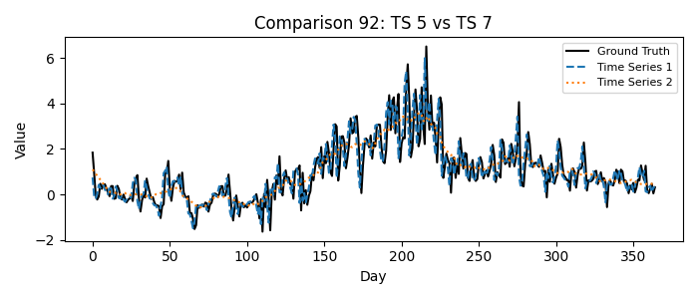

1 = Time Series 5, 2 = Time Series 7

Please fill in your choice (enter 1 or 2): __1

## Comparison 93: TS 4 vs TS 17

Which time series better matches the ground truth?

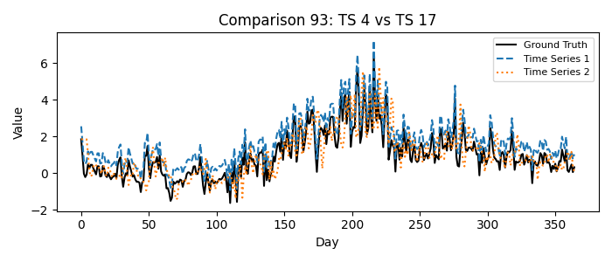

1 = Time Series 4, 2 = Time Series 17

Please fill in your choice (enter 1 or 2): __2

## Comparison 94: TS 0 vs TS 12

Which time series better matches the ground truth?

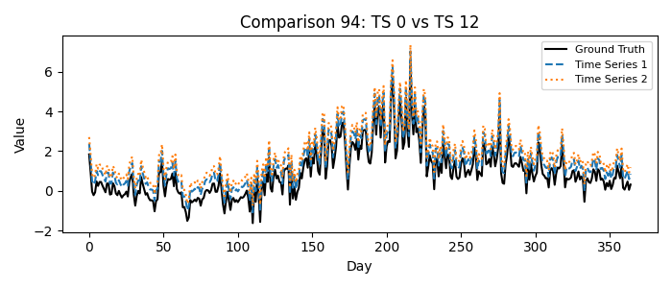

1 = Time Series 0, 2 = Time Series 12

Please fill in your choice (enter 1 or 2): 1__

## Comparison 95: TS 0 vs TS 11

Which time series better matches the ground truth?

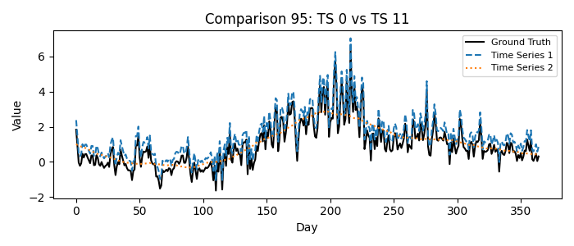

1 = Time Series 0, 2 = Time Series 11

Please fill in your choice (enter 1 or 2): _1_

## Comparison 96: TS 0 vs TS 10

Which time series better matches the ground truth?

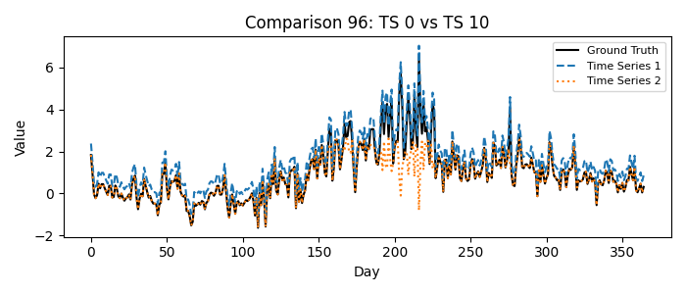

1 = Time Series 0, 2 = Time Series 10

Please fill in your choice (enter 1 or 2): 1__

## Comparison 97: TS 0 vs TS 14

Which time series better matches the ground truth?

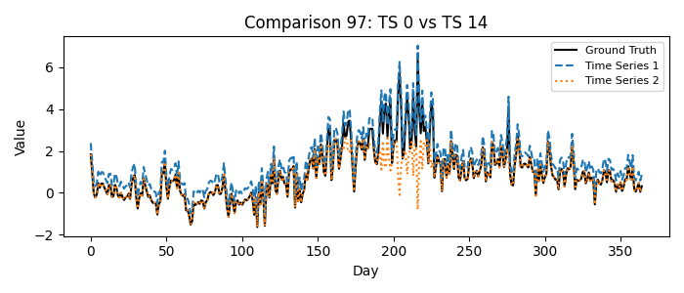

1 = Time Series 0, 2 = Time Series 14

Please fill in your choice (enter 1 or 2): _1_

## Comparison 98: TS 5 vs TS 6

Which time series better matches the ground truth?

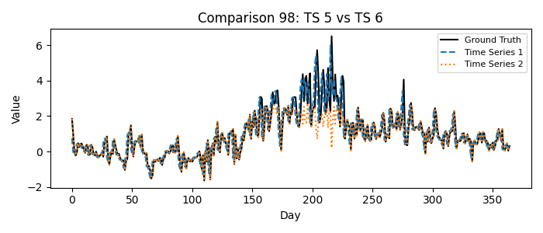

1 = Time Series 5, 2 = Time Series 6

Please fill in your choice (enter 1 or 2): __1

## Comparison 99: TS 0 vs TS 15

Which time series better matches the ground truth?

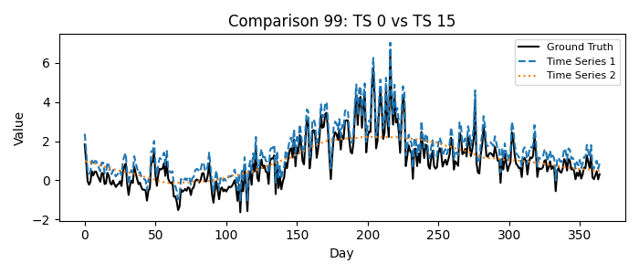

1 = Time Series 0, 2 = Time Series 15

Please fill in your choice (enter 1 or 2): __1

## Comparison 100: TS 1 vs TS 14

Which time series better matches the ground truth?

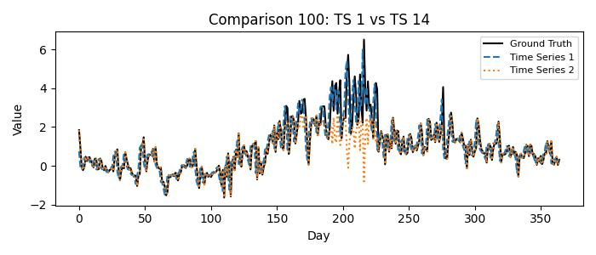

1 = Time Series 1, 2 = Time Series 14

Please fill in your choice (enter 1 or 2): 1__